**Chapter 4: Energetic Maths.**

1. **Introduction**

When asked what is the most important invention ever made by humankind, apart from my own personal favourite of calculus (which strangely never gets many votes), one invention that always figures very highly is fire. It was fire that first allowed us to release energy in meaningful amounts. This could then be used for cooking, heating, lighting and the manufacture of new materials such as metals. Since then our whole civilisation has both relied on, and has been defined by, the need to obtain energy. Some of this has come from natural sources such as the wind, the sun directly, or from flowing water. Until recently the bulk of the rest of our energy came from burning wood (or peat) and then fossil fuels such as coal, oil or gas. The industrial revolution was triggered by the discovery that through the use of the transition of water into steam, the *heat energy* released by this process could be turned into *mechanical energy* and this could be used to power the great machines of the industrial age including lathes, mills, pumps, lifts and, of course, locomotives. During the 19th Century, the work of Michael Faraday at the Royal Institution in London (where I am the Professor of Mathematics) led to the discovery that this mechanical energy, when coupled to a generator, could lead to electrical energy. Through the work of many others, most notably Edison and Tesla, we then saw a revolution at the end of the 19th Century and the start of the 20th with the widespread adoption of electricity as the primary means of both transmitting and using energy. Now electricity is generated through a wide variety of mechanisms including wind, solar, hydropower, fossil fuels, and now also including nuclear power, tidal power, wave power, hot rocks and bio-fuels. Of these fossil fuels account for about 80% of our energy production, hydropower, wood nuclear for just under 20% and the remaining 2.5% by renewable sources. Most of the world uses electricity (although about one Billion people have no access to electrical power). The huge advantages electrical energy has over mechanical (and most other forms of) energy is that it can be transmitted over huge distances with almost no loss, and it can be (relatively) easily controlled. This has led it to be widely adopted as the primary source of the world’s energy.

The annual consumption of electricity in the UK is about 360 TWh[1] (predicted to rise to 730 TWh in 2050), and the peak demand is around 70 GW, depending upon the time of day and the day of the week. This electrical power is supplied over a complex network starting, usually, with power being generated at a power station. This is then transmitted over a high voltage network, before being reduced in voltage and distributed to commercial, industrial and residential consumers. Maths is vital in ensuring that the lights always stay on as the planners of the grid need to solve a large number of nonlinear differential-algebraic equations, described on a complex network (with 30 million nodes representing different households, industries and other users of electricity), to work out how much electricity can be generated, distributed and stored. However this is not easy, as electricity must be consumed as soon as it is purchased, it cannot be stored in large quantities and the user has a very low tolerance to interruptions in the supply. These challenges are going to increase significantly in the future with a greater emphasis on low Carbon generation, a much more distributed supply network (with a significant increase in lower power generation from renewable sources such as solar and wind often at a domestic level), the increase in the use of electric vehicles, an increase in local electricity storage, and the advent of the SMART Grid [4] in which users both have much greater control over their energy demands and also supply much more information to the Grid. For the future planning of the National Grid this raises important questions. For example how should we expand our power system and what will happen 5, 10 or even 20 years from now (remember that it takes a long time to build a power station, and it will be in use for a long time). Furthermore, where should the generating plants be constructed, for both economic and also environmental reasons. In addition, what will be the configuration of the transmission lines, what voltage will they be using and will we see a change from alternating current to high voltage direct current in the future?

In this Chapter we will see how the grid system works and the mathematical models behind it. I will explain how (by using tipping points) how power cuts can happen (with the example of the US NE coast blackout) and will show how using a mathematical model can prevent this happening in the future. We will then look at the challenges and opportunities presented by renewable energy, the SMART grid and electrical vehicles. There are many challenges for the future supply of energy in as clean a form as possible, and mathematical models give us a vital tool for addressing them.

1. **Where does electricity come from and where does it go to?**

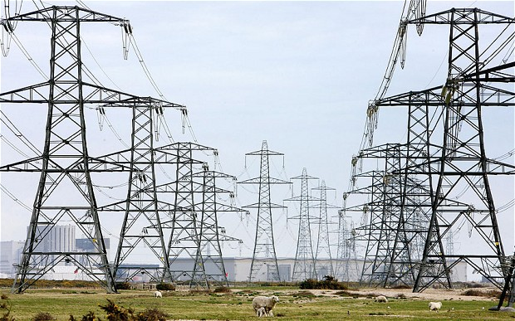

Electricity is mainly generated in large power stations at a very high voltage. In the UK there are around 180 of these. A typical large power station is either burning gas, is coal fired, or is nuclear, and can generate around 2GW of electrical power. At present the largest supplier of electricity in England at 34.5% comes from gas power stations and in Scotland by hydro electric power. Coal fired stations in the UK, once dominant, now only contribute a small amount of 1.6% of the total electrical power. Nuclear contributes about 17%. The value of 2GW is similar to the power production of a typical large hydro electrical plant, but the Three Gorges hydroelectric plant in China produces a staggering 22 GW. A large wind farm generates about 300 MW of power, and wind energy is rapidly increasing in its overall contribution to the total power generated, with wind power amounting to about a quarter of the total energy produced in the UK . In contrast, a domestic solar cell system would produce around 1 kW, although the abundance of Solar power now means that it contributes around 5% of the UK’s power requirements.

Once produced the electricity is transmitted (in the National Grid in the UK) as three-phase AC (using the method invented by Tesla) at high voltage, with the highest voltage being Extra High Voltage (EHV) of 400kV, over a national network of power cables, typically hung from pylons. It is then sold onto the regional companies where its voltage is successively reduced, by transformers in sub-stations, to the High Voltage (HV) of 11 kV and then down to the domestic supply Low Voltage (LV) of 415V and the consumer voltage (in the UK) of 240V. At all times and places it is at a constant frequency of 50 Hz.

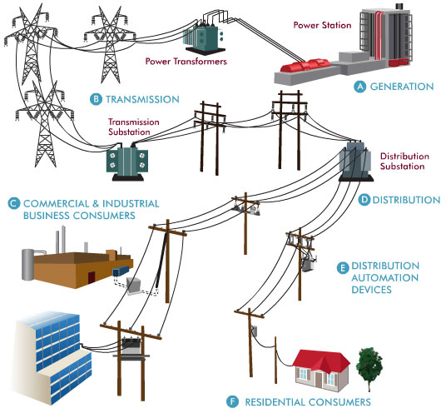

Producing electricity securely, safely, reliably and cheaply, has many challenges. Electricity is difficult to store in large quantities, so it usually has to be used as soon as it is generated. We also have a very low tolerance to any interruption in the electricity supply. Other challenges arise from the extreme interconnectedness of the electricity network, which means that a problem in part of the network quickly becomes a problem for the whole network. Most of the time the process of transmitting electricity proceeds smoothly. However, there are times when the users place a very large demand upon the network. An example of this is an international football match when lots of people will not only turn on their TV sets to watch the match, but will also turn on their kettles at half time, or just after the match finishes. In the figure below we can see the demands on the UK supply by some notable football matches in some recent years. Top of the list was the famous World Cup semi final of England against West Germany, which went to penalties, but was ultimately lost by England [6]. This match is famous for two things. Firstly, Paul Gascoigne’s tears when he received a booking. And secondly for nearly shutting down the UK electricity supply network. Indeed the total change in the demand for electricity during the match was 2.8 GW, which was 11% of the total power delivered by the network and amounted to about 2 Million kettles.

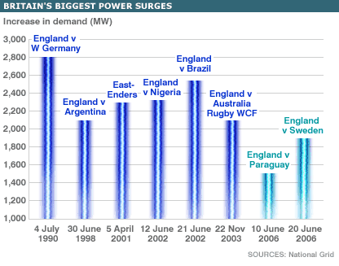

It is the mark of a good electricity supply network that this does not happen, and that the lights always stay on, regardless of the demands placed on the network! Technically this means delivering a secure supply electricity at a near constant voltage and frequency, at all points of the country, regardless of the amount of power demanded from it. Indeed the UK National Grid is very carefully controlled to make sure that the electricity supply remains stable, and the lights have (so far) always stayed on. In the next section we will see why, and the role that maths plays in keeping the lights on.

1. **The complex story of how electricity is transmitted and distributed.**
   1. **The war between AC and DC**

The modern electricity supply network relies on the invention of alternating current (AC) by Nikolas Tesla. In AC the current and the voltage vary sinusoidally with time as seen below, with the voltage varying from a maximum value, to a minimum value and back in one *cycle*

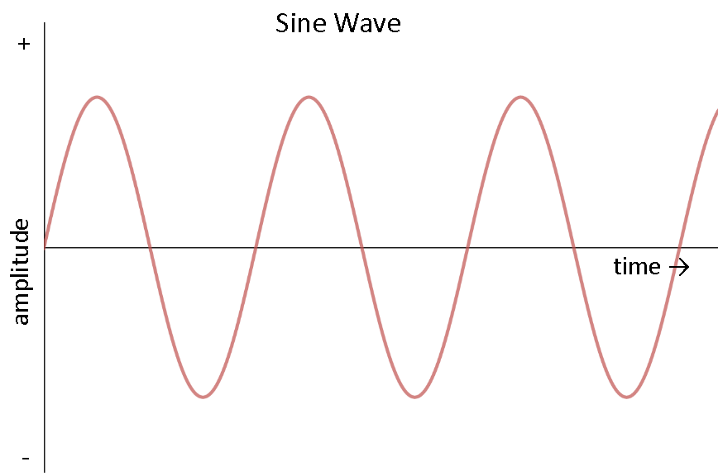

Thus the Voltage V(t) and the current I(t) have the form

where is the frequency of 5o Hz (so that the period of each cycle is 0.02 s) and and are the *phases* of each (which we will return to later), and |V| and |I| are the *amplitudes* of each. We have seen this curve before, in a totally different context, when we looked at the low amplitude swings of the pendulum. It is both remarkable, and a tribute to the universal nature of mathematics, that we see the sine wave over and over again in so many diverse applications.

The reason that AC was originally adopted was that it is relatively easy to transform from a high AC voltage to a low one, and vice-versa, by using a transformer. This can be done with a small loss of energy. A high voltage can then be transmitted at a low current, meaning that the power loss on transmission (which is proportional to the square of the current) is then low. Thus AC could be transmitted over large distances at high voltage with little loss of energy.

The reason for this can be shown by using a mathematical model of the power loss and the power generation. If a wire has resistance R and a current I flows through it then then power loss Ploss in the wire (which is useless and only goes to heat up the wire) is given by



So if you *double* the current through the wire then the power loss *quadruples*.

Now, if the power station produces electricity at a power P and at a voltage V the current I is given by the formula

I = P/V.

So, the higher the voltage at the power station, the lower the current. If we combine these two formulae then we get



As we have seen, a typical domestic voltage in the UK is 240V and the typical voltage of a high voltage power line is more like 400kV. Using the above formula the ratio of the power loss of the high voltage line to that of a domestic line is (240/400 000)2 = 1/ 2 777 777. So using the high voltage reduces the power loss by a factor of nearly 3 million. The mathematical model therefore shows that it makes huge sense to transmit electricity at a high voltage. Only when it is needed to supply a domestic h0usehold is it necessary to transform the electricity down to a lower voltage. This means that electricity can be generated at high voltage efficiently by a large power station far away from a city and transported with very little power loss into the city to be used. In contrast low voltage generation needed lots of inefficient local power stations. In the early part of the20th Century a bitter battle was waged between Tesla (working for Westinghouse) and Edison, about the best way to produce and transmit electricity. Edison favoured low voltage direct current (DC) in which the voltage is constant, claiming that it was safer. (Edison tried to demonstrate this by advocating the use of electricity in the electric chair to execute convicted criminals). Edison built some small local power stations to supply electricity. However, as we could have predicted from the above model, there was a huge energy loss between these power stations and the users. The advantages of AC so greatly outweighed those of DC, that it became widely adopted and is still very much in use today. (It is worth saying that recent advances in power supply design mean that it is possible, by using controlled switching devices called buck convertors, to transform a high DC voltage to a low one with minimal energy loss. This has led to a recent comeback of high voltage DC or HVDC, and this is now being used for the power cable link between England and France.

**3.2 Complex Numbers and their applications**

To represent an AC voltage, electrical engineers make extensive use of *complex numbers*.

If you multiply a positive number by itself, then you get a positive number. Similarly, if you multiply a negative number by itself then you also get a positive number. So at first sight it doesn’t seem to make any sense to ask if the equation

has a solution. However, this little difficulty doesn’t stop a creative mathematician. They can speculate about what sort of number might satisfy this equation, and then try to discover the properties of this number. Later on they may even find a use for it!

Exactly these considerations led the mathematicians of the 18th Century to introduce the idea of imaginary numbers which allow a solution to this equation. The imaginary number i satisfies the equation

Using these numbers we can then solve the equation to give the answer x = 2 i.

A number of the form y i where y is a ‘normal’ or a ‘real’ number is called an *imaginary number*.

A *complex number* z is a combination of a real number x and an imaginary number y i to give

z = x + i y.

In this expression for the complex number z we call x the *real part* and i y the *imaginary part.*

You can add, subtract, multiply and divide complex numbers with the following rules:

(a + b i) + (c + d i) = a+c + (b+d) i,

(a + b i) - (c + d i) = a-c + (b-d) i,

(a + b i)(c + d i) = (ac-bd) + (ad + bc) i,

(a + b i)/(c + d i) = ((ac+bd) + (bc-ad) i)/(c2 + d2).

You can also do calculus with complex numbers (such as integration and differentiation), and use then to solve polynomial equations.

Complex numbers were originally thought to be highly abstract mathematical objects of no possible use. However they are now known to be hugely important in a vast number of applications ranging from Quantum Mechanics to the study of water waves, and from vibrations in engineering structures to animating movies. In particular, they lie at the heart of the mathematical models of power engineering[2].

The reason for this is famous identity [ref Nahin] which was discovered by the amazing Swiss mathematician Leonhard Euler in the mid Eighteenth Century, and which states that

**This identity is almost certainly the *most important formula in the whole of mathematics!***

Its sheer elegance is often illustrated by taking the special case of taking θ = π . In this case cos(θ) = -1 and sin(θ) = 0, which leads to the identities:



These identities unite all of the main numbers in mathematics into one formula. If there was a contest for the best ever formulae then this would win every time! We will see it in application many times for the remainder of this book.

Euler’s theorem has countless applications, and in this Chapter we will see how it is used in power engineering.

The reason in this case is that it allows us an easy way of describing alternating current, along with its frequency and phase. Using this an alternating voltage, as described above, can as the real part of the function

with a similar expression for the current. Here |V| is a constant real number called the modulus or the *amplitude* of V. If z = x + i y then

A convenient way to express this is as

and we call the expression the *complex voltage*.

This single complex number contains two pieces of information, namely the amplitude |V|, and the phase ϕ1, of the voltage. There is a similar expression for the *complex current*. Using this we can now describe how a power network works and how we can use maths to make sure that it operates well.

* 1. **What a power distribution network looks like.**

An example of a small power network, is given below. In this network we have supplies of electrical power from a power stations, many households which are supplied by power from the network, and junctions called *buses.* Each bus will be at a particular voltage. Between the buses there are connections. These can be the high voltage cables that we see proudly marching across the countryside. The cables carry current between the buses, which, as we have seen, is kept low by having a high voltage. Low current leads to much smaller power losses, which is why high voltages are used.

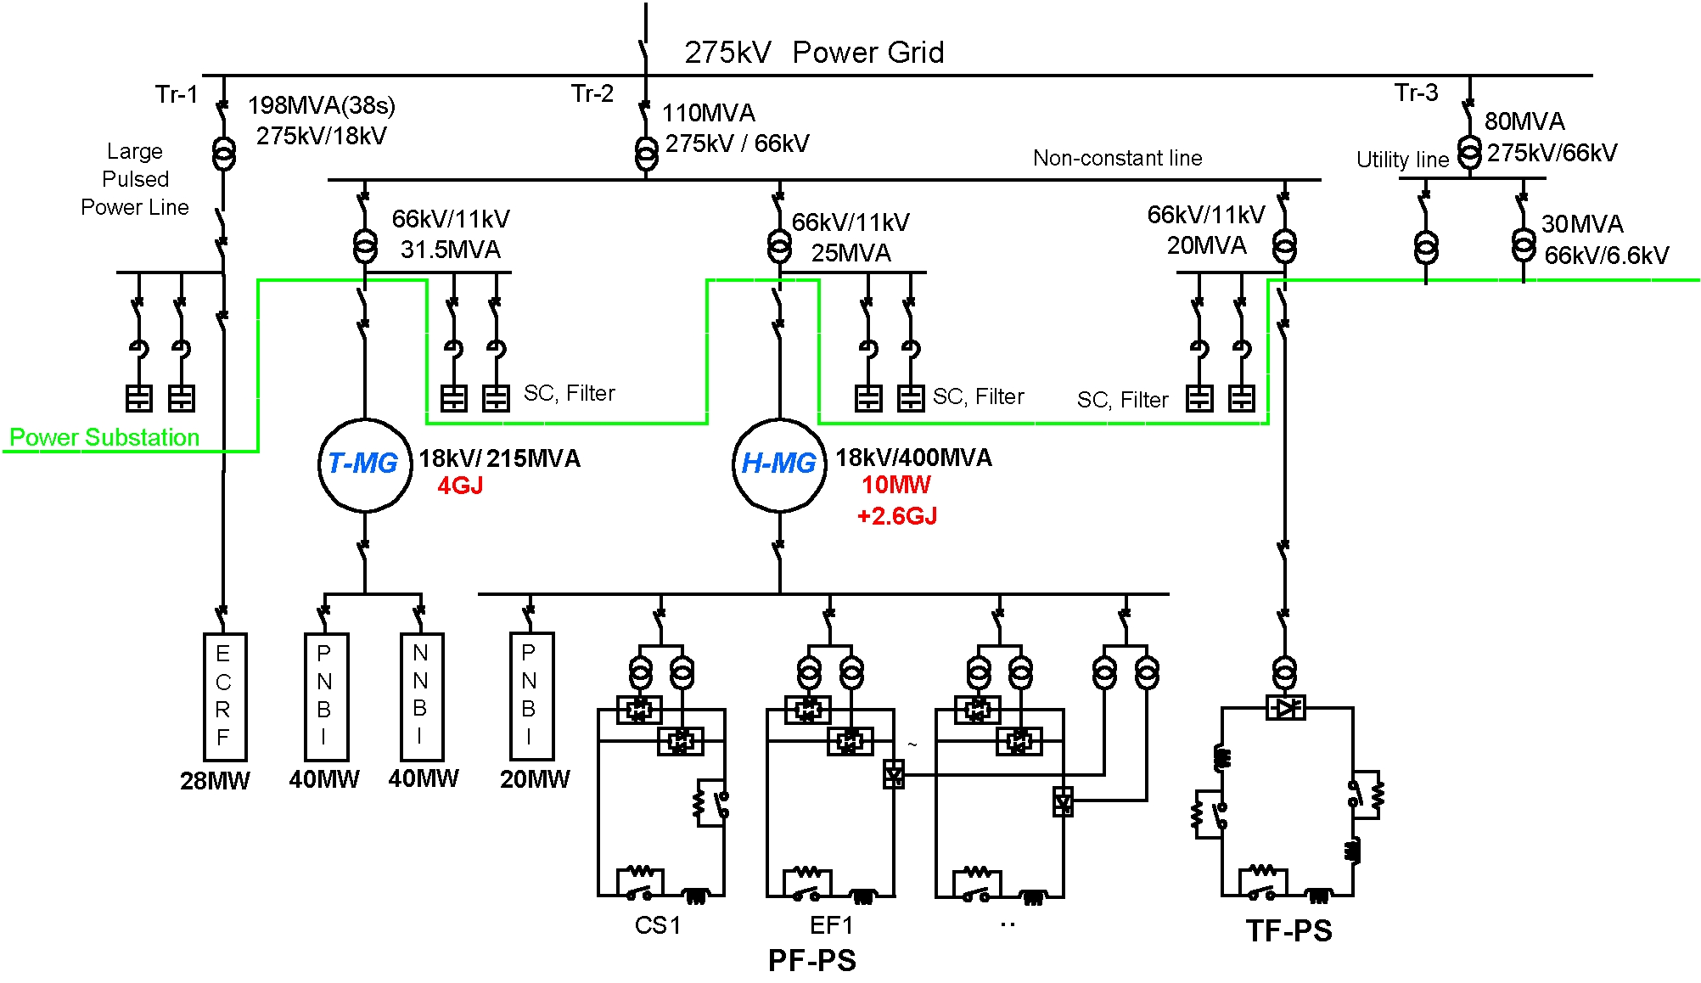

In a typical network there are many buses, which can be power stations, factories, transformers, switches, points where the network changes, and households. In principle there can be one bus for every household, so up to 30 million buses. This immediately gives you some idea of the scale and the complexity of the electricity supply network. At each bus the network needs to supply a certain amount of power. How much this is depends upon the usage and load imposed on the network. We calculate this as follows. Each bus is numbered by an index j=1,2,3, .. N and will have a (complex) voltage . This bus will in turn be connected to many other buses in the network. Typically a (complex) current will flow between the buses labled j and k in the network. The *power* S of this current flow is given by

Here is the complex conjugate of the complex current. If z = x + y i is a general complex number then its complex conjugate is given by

z* = x – y i.

The total power at the jth bus is then given by

This power is in turn a complex number and we write this as

.

Here is called the *real power*, which is the power transferred from the power station and which does work, such as heating your home or running your washing machine.

In contrast is called the *reactive power* and this doesn’t do any work. It is the portion of the total power which returns to the power station in each cycle.

Electrical engineers take the reactive power into account when designing and operating power systems, because although the current associated with reactive power does no work when it gets to you, the user, it still must *still be supplied by the power station*. Failure to produce sufficient reactive power to the electrical grid can lead to lowered voltage levels and under certain operating conditions (as we shall see in the next section) to a compete power blackout.

If the voltage difference between two buses is - then the current flowing between them is given by Ohm’s law. In particular there is (another) complex quantity called the conductance so that

In high voltage cables the conductance is usually close to being a purely imaginary number. This is because these cables are designed to have a very low resistance, but usually have some inductance.

We can now combine the three equations above for the power supply network and we find that the total power supplied to the jth bus is given by the expression:

.

Now, when designing and controlling a power supply network, we know the values of the real power Pj and of the reactive power Qj that needs to be supplied to each bus. This is because the buses represent different types of users, such as households or factories, and we know the usual power demands of each of these. The voltages at each bus then satisfy the equation:

We have finally arrived at the *mathematical model for our power supply network*. It relates the voltages at each bus, to the real and reactive power needed by each bus, and the conductance of the power cables joining one bus to another.

**If we can solve this equation then we can work out the voltages at each bus which are needed to supply the desired amount of real and reactive power.**

This allows a power engineer to be able to simulate the network. In particular to make sure that it can supply enough voltage (and current) to meet the demands of the users of the network. It also tells the engineers which power stations need to ne ‘on-line’ at any one time, and solving it is therefore vital if we are going to get the electricity that we need to keep our houses and factories functioning.

Take a look at the equation. It is nothing other than a large collection of **quadratic equations** for the (complex) voltages (meaning that it is made up of products of one voltage with another). We can therefore understand the complex behaviour of the grid by looking at the complex solutions of quadratic equations and we will do this in the next section.

It is worth noting that an attempt was made a few years ago in the UK to stop the teaching of quadratic equations at school on the grounds that they were totally useless, of no possible benefit to the education of anyone, and that teaching them would simply frighten the students. We illustrate this terrible situation below. This suggestion led to a debate in the House of Commons in the UK in which the merits and disadvantages of teaching the quadratic equation were discussed my MPs. Possibly the first time that an equation has been the subject of a debate! More details of this debate are given in [1]. Fortunately the outcome of this debate was that schools should continue to teach their students about quadratic equations and how to solve them. This is fortunate as, as we can see, we need to solve quadratic equations if we want to keep the lights on!

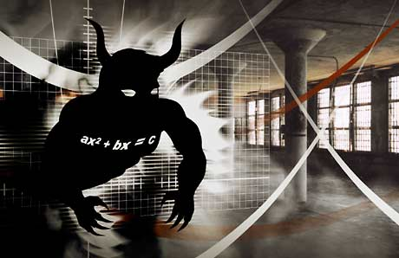

1. **Power cuts and tipping points**

Usually, thanks to careful planning by the National Grid, and other energy companies, the lights do usually stay on. This is due to them being able to solve rapidly the mathematical model equation above and to follow the solution as the demand on the power grid varies throughout the day (including during football matches).

Sadly, however, this doesn't always happen. On August 14th, 2003 a catastrophe hit the North East coast of America [5]. During a storm, an overgrown tree hit a power cable. The safety mechanisms then cut in leading to a local shut down of the power supply to the part of the network closest to the affected cable. Unfortunately, there was a software error in the control room, which meant that the shut down spread and spread. As a result the whole of the North East of America and large parts of Canada were plunged into darkness. In the figure below you can see a satellite image of the North East of America, with the ringed black area showing the black out. The resulting blackout lasted for about two days, and affected an estimated ten million people in Ontario and 45 million people in eight US states. The event contributed to at least 11 deaths and cost an estimated $6 billion.

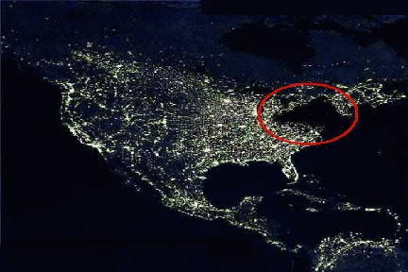

So, could this happen again? One of the main reasons for a power failure is a phenomenon called a *Voltage Drop* when the voltage in the power network rapidly drops to zero. The cause of a Voltage Drop is essentially one of the *tipping points* which we described in Chapter Two. As we might expect from our model, this follows from properties of the solutions of a quadratic equation.

Usually a quadratic equation is written as

and we want to find the solution x. When we meet the equation at school we are told that it may have one, two or no real solutions. These are given by the famous *quadratic formula*:



The quadratic formula has an interesting history. Quadratic equations have been studied since the times of the Babylonians and are recorded on Babylonian cuneiform tablet. (This is because they are related to *areas* and if the areas are those of fields then they become related to land values, and hence to *taxes.*) The original solutions of the quadratic equation were obtained geometrically. However the Indian mathematician Brahmagupta (597-668 AD) derived the algebraic formula above for the solution, which he described using words. The first publication of the quadratic formula was in 1637 by the French mathematician/philosopher Rene Descartes in his book la Geometrie.

The quadratic formula says that the quadratic equation has *two real solutions* if and *no real solutions* if . If then it has two *complex solutions*.

To illustrate this we will look at an equation for which a = 1, b = -2. The two solutions are then given by

There are two real solutions if and no real solutions if . A graph of the two real solutions is given below, with the special point c = 1, x = 1 highlighted.

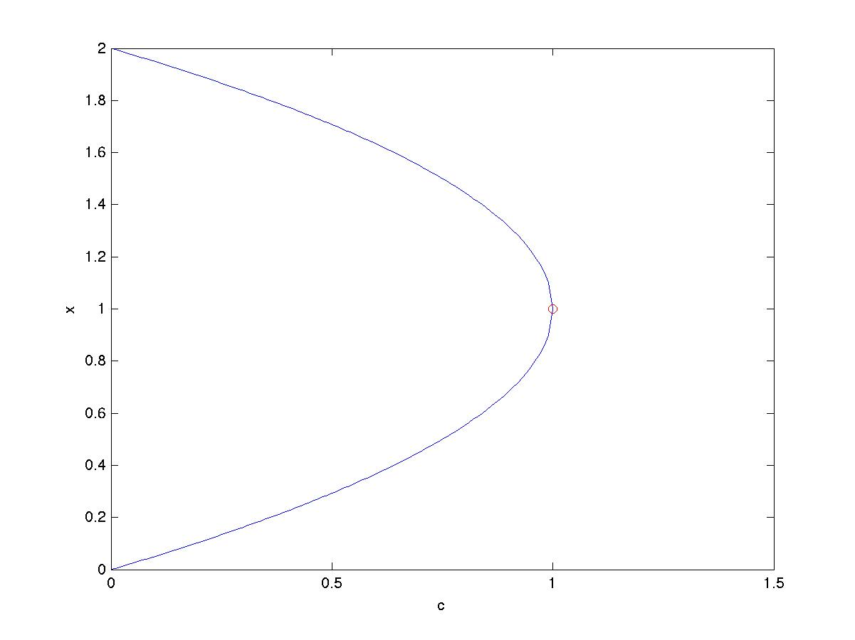

We have seen this point before in Chapter 2. It marks the boundary between when the quadratic equation has two solutions and none and it is a *tipping point* for the dynamical system



In particular if c < 1 then this equation has two fixed point, one of which is stable and the other is unstable. If c > 1 then the dynamical system is completely unstable.

The link between this and the model equation for the power network is as follows. The system of quadratic equations in the model replaces the single quadratic equation above. The differential term dx/dt above is replaced by a similar term which represents the dynamics of the power grid (due for example to the speeding up and slowing down of the generators in the power stations, and the motors in industrial plants). The term c in the quadratic equation becomes the power drain in the network. If the power drain is low then the whole system can operate in a stable state which changes as the power drain changes. However if the power drain is larger than the network can manage to supply, then it becomes unstable, and get a Voltage Drop at the tipping point.

To see this we show below the normalised (with respect to a usual operating voltage) average voltage in a network when it has to supply a reactive power Q to a city. This curve is obtained by directly solving the model equation for the power grid. The three curves correspond on the left to a network with fewer power stations on and thus less available power, and on the right to one with more power stations on and thus more available power. Each of these curves has a *very similar shape indeed* to that of the solution of the quadratic equation illustrated above, complete with a tipping point. This is of course no coincidence as each such curve is given by solving several quadratic equations instead of just one. These curves are given the ‘technical name’ of *nose curves* for reasons which should be obvious.

Each nose curve has, as we might expect, two solutions for a given value of Q before the tipping point. The *upper part* of each of the curves represents (as in the case of the quadratic equation based dynamical system) a stable solution in the normal voltage range, which is where we want to operate the power grid. As the reactive power drain Q increases, so the average voltage V drops, slightly at first, and then more rapidly as the tipping point is reached. When we get to the tipping point there is no solution at all. What happens at this point is that the grid goes into a very unstable state during which the *voltage collapses* and all of the lights go out. It is fair to say that, due to good planning and management by the National Grid Company, the UK has never experienced a widespread voltage collapse. However, it has occurred in both Italy and Sweden as well as in the NE USA, and all because a quadratic equation didn’t have a real solution.

There are other causes of power cuts, for example on 13th March 1989 the particles emitted from a large solar flare so overwhelmed the safety systems of the Quebec power system that a power cut resulted. Quebec also suffered later on from a power cut caused by an ice storm.

1. **The future of energy and its control.**

One of the biggest challenges faced by the energy industry is the transition to a low Carbon technology and a move away from a reliance on fossil fuels (and possibly from nuclear fuels as well). Essentially this means a transition to renewable forms of energy such as wind energy, solar power and other forms of power production such as wave and tidal power. The table below from a report published by the (then) Department Of Energy and Climate Change (DECC) in 2010 [2] shows some possible predictions of future energy production (in GW). Note the high level of wind and solar and also CCS Coal (Carbon Capture and Storage burning of coal).

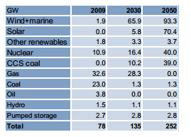

Whilst the renewable sources have significant benefits in the reduction of Carbon Dioxide production, they present a big challenge to the grid. In particular they are an intermittent source of energy, and the amount of energy available from them will always be uncertain. In particular both wind and solar energy are dependent in the short term upon the weather, and in the long term by (amongst other factors) the effects of climate change. This predicted change in the way energy is supplied is combined with a projected significant increase in electricity use, particularly for transport, as we move away from internal combustion engines to electrical vehicles. To meet both the supply and demand problems we will increasingly rely on a diversity of different sources of energy production with (possibly) the majority produced by renewables, but with back up supplies (probably from fossil fuels combined with nuclear energy) and significant redundancy in the network needed to maintain the security of the system. All of this places much greater demands on the control and supply of electricity in an optimum cheap and safe way, and this requires careful mathematics. In part this will be achieved by encouraging the users of electricity to be ‘smarter’ in their use, with SMART meters giving constant reports on electricity usage by individual households. However this does in turn lead to additional mathematical problems. At the moment the EHV (Extra High Voltage) supply network is modelled in computers by solving the quadratic equations in the model system above for several thousands of points, in which the electricity demands of a whole town (and indeed the HV (High voltage) and LV (low voltage) components of the grid) may be modelled as a single point. This is done to allow the calculations to be performed in a reasonable time, so that the behaviour of the network can be predicted over the short time-scales needed to control it, and it is accurate enough in the context of large amounts of electricity being supplied by a small number of big power stations. However, the increased complexity and volatility of the supply (with, for example, many individual households supplying an intermittent amount of electricity to the grid through solar panels on their roof) means that this approach is no longer accurate and electricity supply companies are finding it harder to predict the demands on the grid. There is consequently now a move to develop simulators, which model every single household. This means solving (for the UK) over 30 Million coupled quadratic equations every five minutes. Remember, that school children were being warned about the health effects of just solving one such equation! Mathematically solving this very large system quickly is a very challenging task, even for a super computer, and developing effective methods to do it is the subject of on-going research.

One reason solving this large system is so hard is related to the changing nature of the electricity supply. As I described above, we now have a multitude of different suppliers of electricity, all of which has to be added into the National Grid. Some of this, for example solar energy, or energy stored in batteries, is generated as DC rather than AC. This needs to be converted to AC at the right voltage and, crucially, at the right frequency and phase, to patch into the Grid. This is achieved using devices called power inverters, which use phase locked loops to synchronise the generated supply to the mains. This introduces additional dynamics into the grid, with the possibility of additional instabilities and lack of security of the supply. To study this we augment the quadratic equations above with additional *differential equations* and study these using the mathematical theory of dynamical systemsthat we talked about in Chapter Two. As we saw in this chapter, under some circumstances dynamical systems can have chaotic solutions. It is an intriguing, and disturbing, question as to whether the grid could behave chaotically under certain conditions [3].

1. **The answer is (maybe) blowing in the wind**

Perhaps the most promising (new) source of renewable energy at the moment is wind power. We can see in the table above that it is predicted to become *the* dominant source of energy by as early as 2030. A large off-shore wind farm can produce large quantities of electrical power, in the order of 500 MW, and wind power can in principle, be available all day and night, most days of the year. Mathematics is used in a number of ways to make wind power more effective.

A set of turbines from the Thanet off-shore wind-farm is illustrated below.

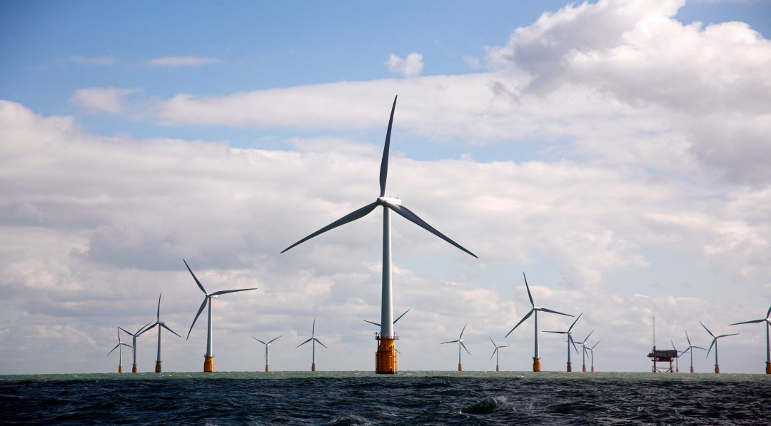

These turbines are in a very harsh environment. As well as the forces from the wind, which are required to turn the blades of the turbine, the turbines also have to cope with the force of the sea. In particular, as well as responding to the ‘average’ sea and wind conditions needed to produce electricity, they also have to deal with extreme conditions, including the intense ‘100 year storms’ which may well occur in the lifetime of the wind farm. This requires careful calculation, both to construct strong enough structures able to deal with the forces involved, and also to predict the nature of the 100 year storms. The latter requires the use of the mathematical/statistical theory of *extreme events* which we also looked at in the last Chapter.

Large wind farms are built off-shore in part because that is where the strongest and most consistent wind is to be found. On-shore wind-farms have to be very carefully sited to receive anything like the same amount of reliable wind. Unfortunately some of the best locations for these farms, from the point of view of producing energy, are also some of our most beautiful and/or environmentally sensitive areas. Building a large wind-farm there would be at best highly controversial and counter productive. It follows that it is essential to maximise the potential of those wind-farms which can be built on on-shore sites.

There are many ways in which mathematical modelling can help in the design, control, and operation, of a wind farm. The power generated by a wind turbine is mainly determined by the average wind speed. Higher wind speeds rotate the turbine blades faster, meaning that they can deliver more power (unless the wind speed is so high that the turbine has to be shut down).

The model equation for wind power P (in Watts) in a wind of speed V (in metres per second) is given by



Here ρ is the density of the air, A is the area of the turbine, Cp is the coefficient of performance (related to the shape of the blades) and E is the efficiency of the turbine gearbox and generator.

The reason for the cube of V in this equation is that the power per unit area of the wind is proportional to its kinetic energy times its momentum. This formula predicts that if the wind speed doubles, then the power extracted from it increases by a factor of eight. This is an enormous increase, and one of the reasons that wind power is such a promising source of future energy. The model equation for wind power allows us predict how much power the wind farm will deliver *if* we can predict the wind speeds.

It is also interesting to ask why most wind turbines have three blades. The reason is two-fold. The more blades that a wind turbine has, the heavier it is and the more air resistance there is to move the blades. So it makes sense to have as few blades as possible. However, if a turbine has only two blades then it can easily become unbalanced when there is more wind loading on one blade than the other. The optimal solution is three blades, which is more stable than two because three blades better spreads the wind load, and has less air resistance than four blades.

Wind turbine blades are typically glued together. Another mathematical model, then allows us to calculate what the maximum wind loading is on the blades. This gives information to the manager of the wind farm on what wind speed means that the wind farm needs to be shut down to keep everything safe.

The above discussion means that to know both what electricity supply from the wind farm is likely, and how it is best matched to the demands of the grid, and also when the wind farm may need to be shut down, then we must solve the seemingly impossible task of accurately predicting the wind speed at the precise location of the wind-farm. As an example of the magnitude of this challenge, here is a plot of the seemingly very erratic wind speed given hourly at a single location over a period of two years [7].

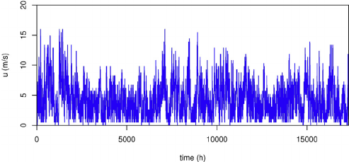

In the last chapter we looked the mathematics behind weather forecasting in which the wind is predicted about 5 days ahead, on a grid with a resolution of about 1.5 km. Unfortunately for a wind-farm this prediction is unlikely to be accurate enough for their specific location.

However, mathematical help is at hand. What the wind-farm and power company managers often need to know is not what the wind will be doing at their location tomorrow, but instead what it will be doing in the *next few hours*. Furthermore, the manager has a lot of data at their disposal, namely the wind speeds at their precise location, which they need to know to know to be able to run the farm at all (and which they can measure directly from the wind turbines). This question of the short term forecast can then can be tackled by using statistical and *machine learning methods*. These methods take the great mass wind data at the location gathered over a period of several months, and then train a statistical (typically an *auto regressive moving average* ARMA model) or a machine learning model (typically a neural net) on the data. These statistical or machine models are highly effective in making short term predictions of the wind local to the site of the wind-farm. In fact over the next four hours they will typically out-perform a more traditional weather forecast. In much the same way that the most accurate way to tell what the weather at your house is *right now* is simply to look out of the window. Because of this statistical and machine learning models are now being used very effectively by the wind power industry. It is the continued use of mathematics in this way which is helping to make wind power a viable source of mass energy in the future.

However, if you want to know the weather *tomorrow* then a traditional forecast based on a mathematical model (the Navier-Stokes equations) is currently more accurate. It remains to be seen whither in the future the use of statistics or machine learning will replace more traditional models for the five day forecast.

1. **Conclusions**

Energy matters to all of us, and the challenge of supplying enough energy in a clean and safe way, is one of the greatest challenges faced by humanity. Energy supply networks are already highly sophisticated, and will get more so as the way in which we use and supply electricity is changing rapidly. To deliver a secure supply well into the future will require equally sophisticated mathematics. However, the bottom line is, that to keep the lights on we all need to be able to solve (lots of) quadratic equations [1].

1. **References**

[1] C. Budd and C. Sangwin, *101 Uses of a quadratic equation*, (2004),Plus Maths magazine

https://plus.maths.org/content/101-uses-quadratic-equation

# [2] F. Li, *Demand side response, conflict between supply and network driven optimisation,* Poyry, University of Bath report to DECC, November 2010

# [3] C. Budd and J. Wilson, *Bogdanov-Takens bifurcation points and Silnikov homoclinicity in a simple power-system model of voltage collapse,* IEEE Transactions on Circuits and Systems I: Fundamental Theory and Applications, 49, (2002), 575-590

[4] For details of the SMART Grid see https://en.wikipedia.org/wiki/Smart_grid

[5] The NE US blackout is described in the website https://en.wikipedia.org/wiki/Northeast_blackout_of_2003

[6] The World Cup semi-final match close run for the National Grid, is described in the article http://news.bbc.co.uk/1/hi/uk/5059904.stm

[7] C. Skittides and W-G Fruh, *Wind forecasting using principle component analysis,* https://www.researchgate.net/publication/261759110_Wind_forecasting_using_Principal_Component_Analysis

1. A kilo Watt Hour (kWh) is the amount of energy required to supply a kilo Watt (the rough power consumption of a typical household) for one hour. 1 kWh = 3.6 M Joules. Your electricity bill will usually be given in kilo Watt hours, typically around 9000 kwH per year . A TWh is one Tera Watt hour, which is one billion kilo Watt hours.
2. In power engineering the convention is usually to use j to represent an imaginary number to avoid confusion with current denoted by i. However in mathematics it is conventional to reverse the situation and to use i for the imaginary number and j for current. It is pointless to argue which is better (or worse), but it is a shame that this separation exists between mathematics and engineering. Without making any judgment one way or the other as to which is best, I will use the mathematical convention in this chapter. However, I’m instantly happy to switch my allegiance when I’m working with power engineers. Indeed, not so long ago, I was one myself.